Technical Datasheet Input / Output Modules with MQTT Protocol with Ethernet Interface
The IO Module communicates via an Ethernet Interface and is designed to interface seamlessly with other MQTT-compatible devices. The module acts as an input/output device that bridges the MQTT network and the connected gateway, enabling real-time data exchange over the MQTT protocol. This Digital I/O module is robust, energy-efficient, and user-friendly, making it ideal for a wide range of IoT applications. It supports both digital inputs, and Digital Output allows users to easily publish and subscribe to topics on an MQTT broker, facilitating communication with other devices, cloud platforms, and remote monitoring systems.
8 Port DI And 8 Port DO Module with MQTT-Ethernet:
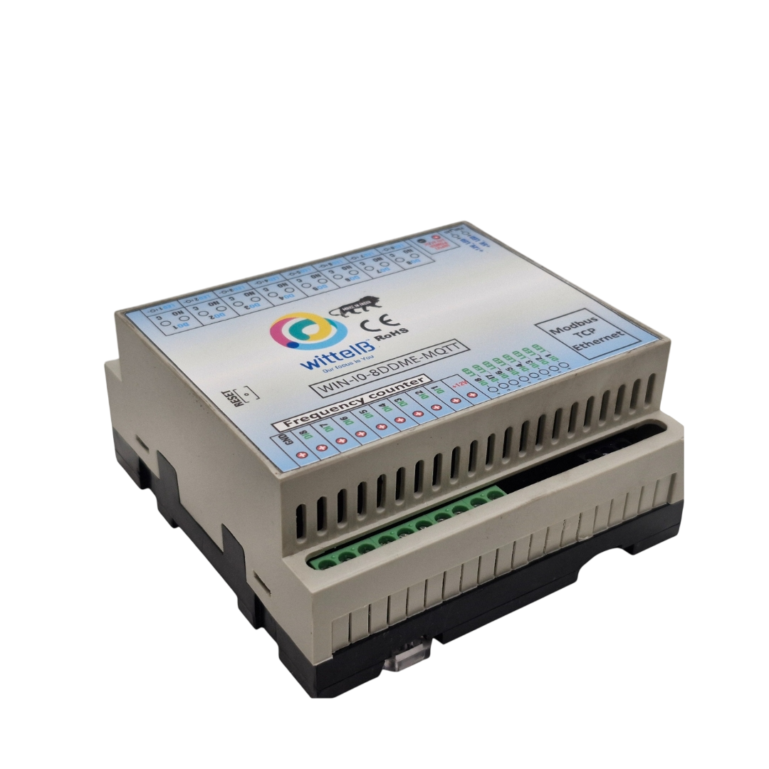

The IO modules are mounted on DIN rail mountable casing and with exposed connectors and LED indicators.
The design of the modules incorporates ‘resettable Fuses’ to safeguard against sudden High Voltage spikes. The board also has ‘reverse polarity’ protection both for input Power connector.
The communication port also has signal isolation and additional Jumper for ‘end of line’ 120 ohms termination resistance which may or may not be used.
Specifications
General:-

I/O Connectors 2 Pin 5.08 mm pitch pluggable screw terminals.
Dimensions 110 mm L x 110 mm B x 50 mm H
Power Input Power – 9-36 V DC
Typical – 12V DC @ 1A
Operating Temperature 0 – 60° C (32 ~ 140°F)
Storage Temperature -20 - 70° C (-4 ~ 158°F)
Storage Humidity 5 ~ 95 % RH, non – Condensing
Certifications 

Relay Output:-

Channels 8
Contact Form 1A, 1C
Contact Material Ag Alloy
Contact Capacity 10A @ 240VAC, 10A @ 28VDC
Coil Voltage 5 – 12 VDC
Coil Power 0.36 W
Insulation Resistance 250MΩ
Electrical Life 1 x 10^5
Mechanical Life 1 x 10^7
Operating Time 7 msec, Max 15 msec
Release Time 2 msec, Max 6 msec

DI Inputs:-

Channels 8
Sense Voltage 3.3 – 30 VDC
Sense Logic Logic ‘0’ = <1 VDC, Logic ‘1’ = >3.3 VDC
Isolation Optically isolated
Response Time 2 msec, Max 6 msec

Technical Specifications:-
- MQTT Protocol Support: Fully compliant with the MQTT protocol, supporting both MQTT 3.1.1 and MQTT 5.0.
- Ethernet Connectivity: Standard Ethernet port (10/100 Mbps) for stable and high-speed data transmission.
- Low Power Consumption: Optimized for low power usage, ideal for battery-operated or energy-efficient applications.
- Easy Integration: Supports standard libraries and tools for easy integration with existing systems.
- Message Retention & Quality of Service (Q o S): Supports various Q o S levels (0, 1, 2) to guarantee message delivery.
- Secure Communication: Support for TLS/SSL encryption for secure communication with MQTT brokers.
- Real-time Data Handling: Efficient, real-time messaging with minimal delay.
- Compact Form Factor: Small and lightweight, designed for embedded systems.
To set up MQTT over Ethernet and find a device's IP address using its MAC address, you'll follow these general steps. This involves setting up an MQTT broker (e.g., Mosquitto, MQTTX, or another broker), connecting devices to the network, and using the MAC address to find the device’s IP. Below is a detailed procedure for setting up MQTT with Ethernet and using a MAC address to find the IP address of a device.

- How To Find the IP Address using MAC Address.

1. Open an IP Scanner Tool
Open an IP scanner tool like Advanced IP Scanner on your device. You can also use any other IP scanner software if you prefer.

2. Scan Your Network
Click the "Scan" button to scan the devices connected to your local network. The scanner will list all devices, showing their IP addresses and MAC addresses.

3. Locate the Device by MAC Address
Look for the device using the MAC Address that was provided with the device. The MAC address will be unique to that device, so it will help you identify it.

4. Find the IP Address
Once you locate the device by its MAC address, you will see the IP Address next to it. This is the IP address assigned to the device on your network.

5. Use the IP Address
Enter this IP address in your any Internet Browser or network configuration to connect to the device.

Note: You can refer to the image provided, where the MAC address and its respective IP address are clearly listed.

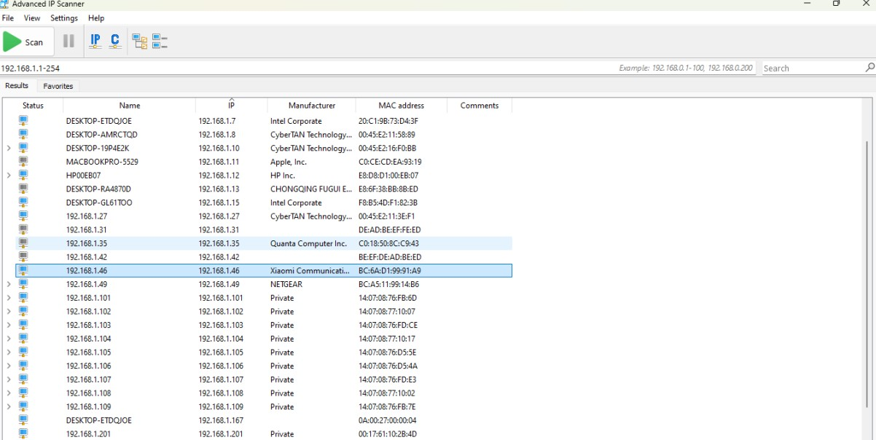
- Configuration Process:-
- For Configuration Enter IP 192.168.1.254.
- You will get this type of page as shown in the image(1.1)

- After Entering the ip You will see interface as shown in the image.
Note:- (For more help you can refer below image1.1 for login)

- After Entering the ip You will see interface as shown in the image.

Note: - (For more help you can refer below image1.1 for login)

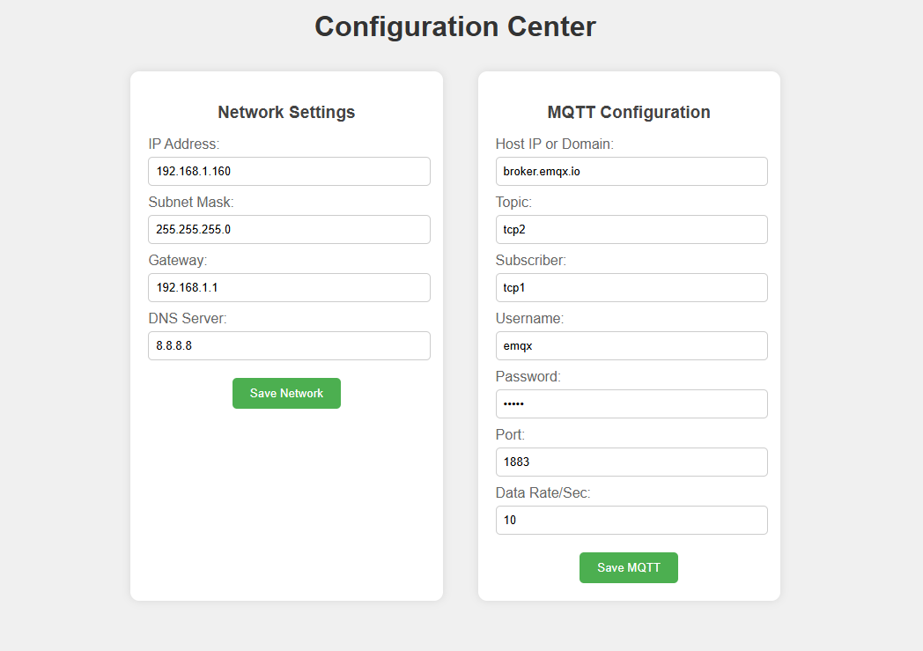
192.168.1.254

Image (1.1)

Configuration Centre

Network Settings:-

- IP Address : (Example:192.168.1.254)
Assign a valid IP Address in your LAN range.

- Subnet Mask: (Example:255.255.255.0)
Usually 255.255.255.0 for most offices and home networks.

- Gateway: (Example: 192.168.1.1)
Enter your routers IP Address.

- DNS Server: (Example: 8.8.8.8)
Google DNS or your local DNS server.

- Click Save Network to Apply Settings. The device will restart with new network Configuration.

MQTT Configuration:-
- Login Prompt
When you open the device's details page, you will be prompted to enter a username and password.
- Default Username
The default username is usually admin.
- Default Password
The default password is typically admin or password.
- MQTT Port
The default MQTT port is 1883 for unencrypted connections.
For secure MQTT over TLS, use port 8883.
- Topic Name
Ensure you configure the correct topic name where digital i/o data will be published.
For example, if you set the topic to “aitcp”, you will receive analog and digital data on that topic.
- Subscriber:Topic where device will listen for commands to operate relays.
- Data Rate:
The data rate refers to how often the device publishes messages. You can set it to a specific interval, such as every second or every few seconds, depending on how often you want the data to update.
Note: (Username Password is optional).

- Click Save MQTT to store MQTT Settings. The device will attempt to connect to the broker with provided details

- Factory Reset : If you forgot the device IP or Enter the incorrect Network /Mqtt Settings you can restore the device to factory defaults using Reset Jumper.

- Steps to reset:
- Power ON the device
- Place Reset Jumper in Reset Position
- Press RESET button
- Remove jumper
- Power On Device

- Settings will be restored

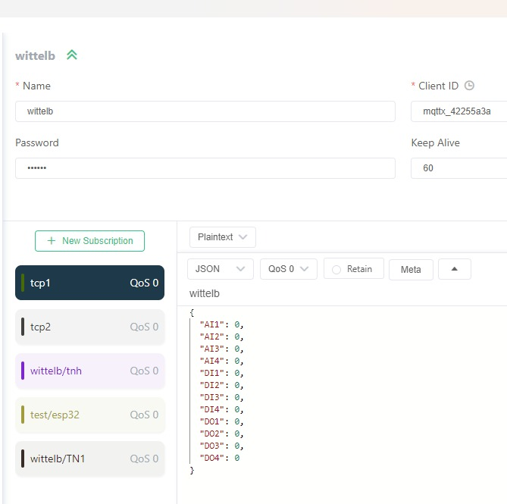

• Here you can see the digital input data in JSON format. Similarly, you can view both digital output and digital input data of all 16 channels in JSON format.

Relay Control via MQTT
To control relays through an MQTT cloud system, you need to subscribe to the appropriate topic. Upon receiving messages on the subscribed topic, the device will interpret the data and act accordingly to control the relay states.
Operation Process:
- Subscription to Topic: The device subscribes to an MQTT topic (e.g., wittel_sub), where it listens for incoming messages.
- Response Format: When the MQTT message is received, the device will parse the JSON payload to determine which relay to turn ON or OFF.
The response for controlling the relay is sent in the following format:
Format:

{
"DO0": "1",
"DO1": "1",
"DO2": "0",
"DO3": "0"
}

• To turn ON a relay, send a value of “1”.
• To turn OFF a relay, send a value of “0”.

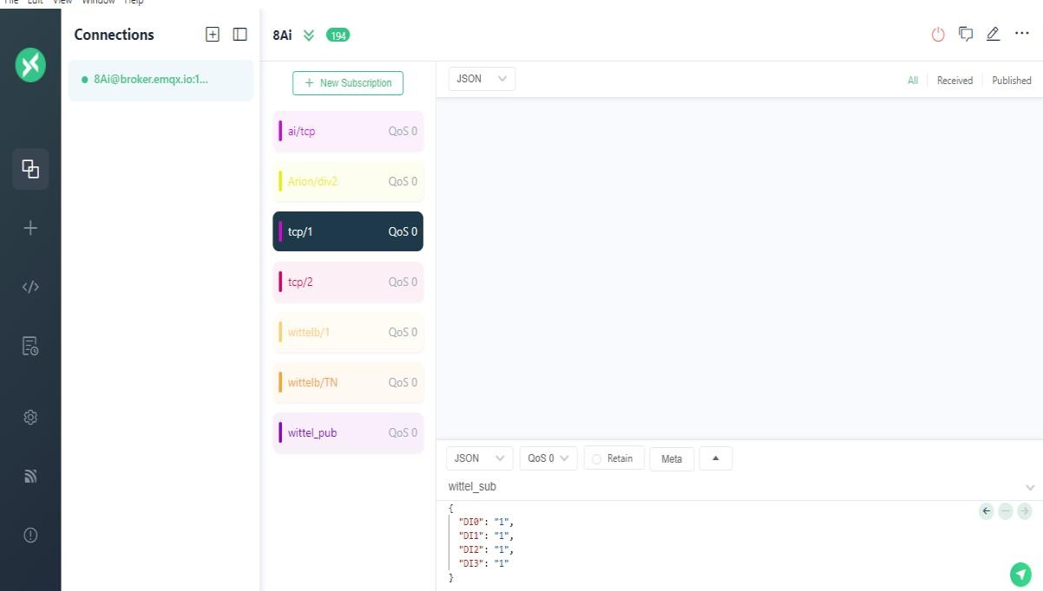

DI

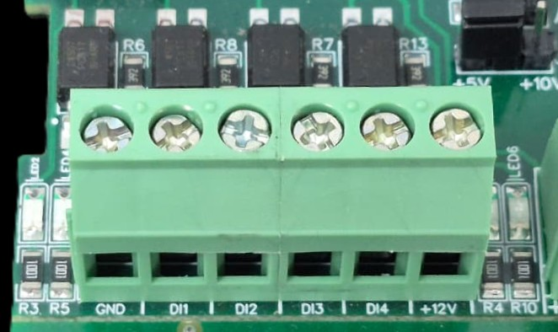

I/p device
I/p device
I/p device
I/p device

- Operation: The module provides four isolated input channels (DI1–DI4) for sensing external signals or dry contacts. These inputs are opto-isolated for circuit protection.
- Terminal Layout:
  - GND: Common Ground reference.
  - DI1 – DI4: Individual Digital Input channels.
  - +12V: Internal reference voltage for sourcing "Dry Contact" switches.
- Wiring Options:
  - Dry Contact: Connect a switch between the +12V terminal and any DI pin.
  - External Voltage: Connect the external signal to a DI pin and the external ground to the GND terminal.
- Voltage Rating: The input circuitry is rated for a maximum of 80VDC. Ensure external signals do not exceed this limit to prevent damage to the isolation ICs.

DO

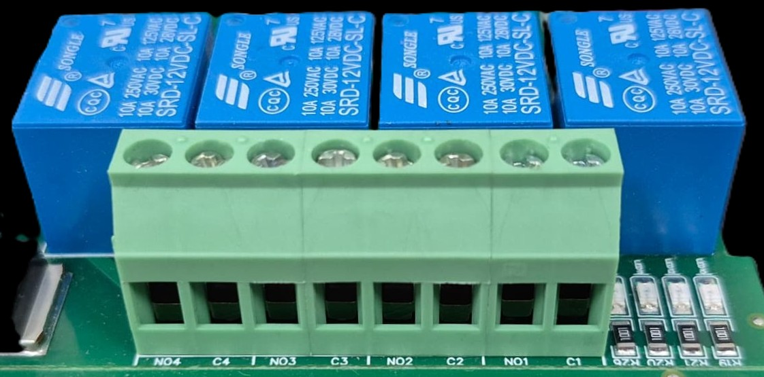




L
O
A
D
N

P
L
O
A
D
N

P
L
O
A
D
N

P
L
O
A
D
N

P

- Digital Output (DO) operation: Each channel provides two terminals: C (Common) and NO (Normally Open). When the relay coil is energized, terminal C is internally connected to NO, allowing current to flow. When the relay is de-energized, the connection between C and NO remains open, and the load stays OFF.
- Load Wiring Connections:
  - AC Load Connection: The AC Live (Phase) wire should be connected to terminal C. The load is connected between terminal NO and Neutral (N).
  - DC Load Connection: The positive supply (+V) should be connected to terminal C. The load is connected between terminal NO and Ground (GND).
- Crucial Safety Recommendation and Rating: It is strongly recommended to switch the Live (Phase) conductor in AC applications to ensure the load is safely de-energized when the relay is off.
Note: Ensure that the connected load does not exceed the relay’s contact rating of 10A @ 250VAC (or 10A @ 125VAC) or 10A @ 30VDC (or 10A @ 28VDC).

DO 1 DO 2 DO 3 DO 4 DO 5 DO 6 DO 7 DO8
I/P Power 9-36 V DC
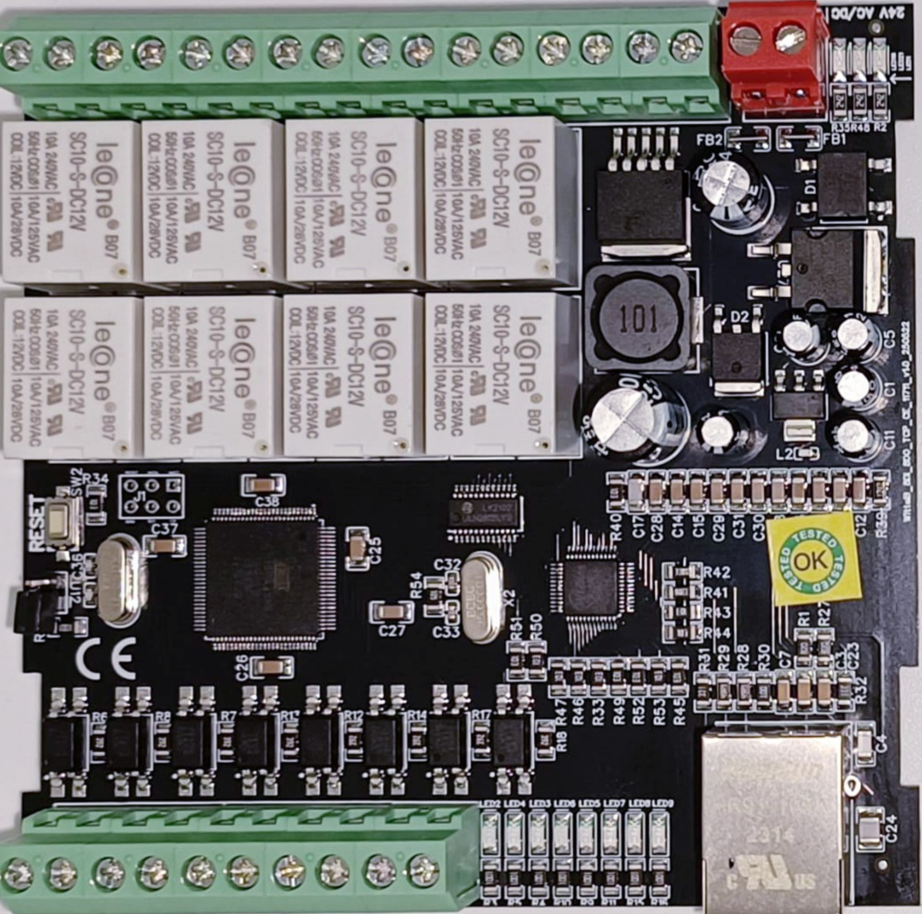
Default IP Reset Jumper

GND DI8 DI7 DI6 DI5 DI4 DI3 DI2 DI1 +12v
Modbus TCP Ethernet

Note:- Configuration Guide is separately provided for the configuration of the module.

Contact Information
Augmatic Technologies Pvt. Ltd.,
Plot no 6, Shah Industrial Estate II,
Kotambi,
Vadodara – 391510.
Email – Sales@wittelb.com
Support E.: support@wittelb.raiseaticket.com / M.: 9403892805

